## fcusMerchant

Scoping start date: N/A

Implementation Completed Date (Go live date): N/A

MSA Signature Date: Mar 31, 2024

ERP**: Bespoke then to Dynamics**

Tax Integration: No Tax

### 

### 

GTM POC: Royce  
Implementation POC: Royce

ERP: Other – SailPoint

Tax Integration: N/A

### 

### 

### Key people at Merchant

### Huy Huynh (VP of Finance)

* Brenda Leto (Project Finance)
* Christopher Chen (New hire for finance)
* Serey Kim (AR automation)
* Jennifer Lleva (AR automation)

### 

### Company summary

Econolite is a company that develops traffic management software to improve mobility, reduce congestion, and improve quality of life. Their products include transportation system design, field installation, system integration, operations and maintenance, and management software. Econolite also works with municipalities to build a safer future using intelligent technology.

AM Notes

* Larger / Enterprise account for Tabs (ACV ~$27k)
* [Econolite x Tabs | Partnership](https://docs.google.com/presentation/d/1SaMqJ6f1V75IpPRUICr-wMCdN5M61l6GpHTW19kL9V4/edit#slide=id.g2c56b4424da_0_0)

### Billing model

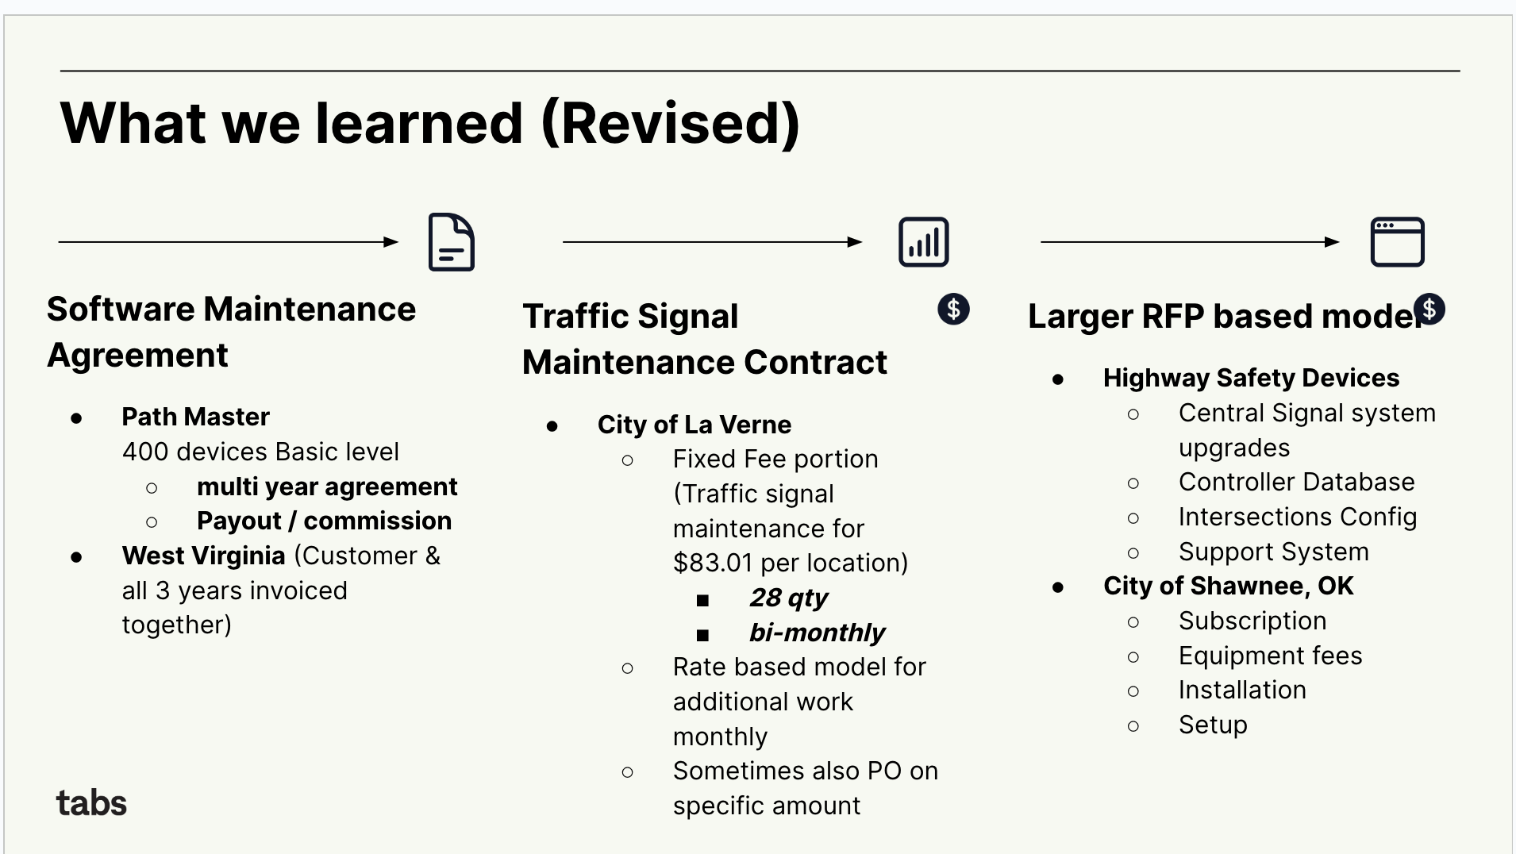+

**Business Types: Software Maintenance Agreement (SMA)**

* **If you need a couple reference customers, check out the following contract**
  + **F4319322-0884-44ca-b691-0379ce755da5**
  + **2d98df31-e734-44dd-9c7a-05e65d5cd9ec**
* **Guidance on Customer name -** It’s always on the section below (highlighted)
  + They do not have an ERP linked, so please create customer
  + Use the naming convention before “hereafter referred to as “Agency”)
  + Check for Path Master (in this case, **Path Master** is a distributors)
    - Create a sub-customer based on contract and associate it as sub-customer

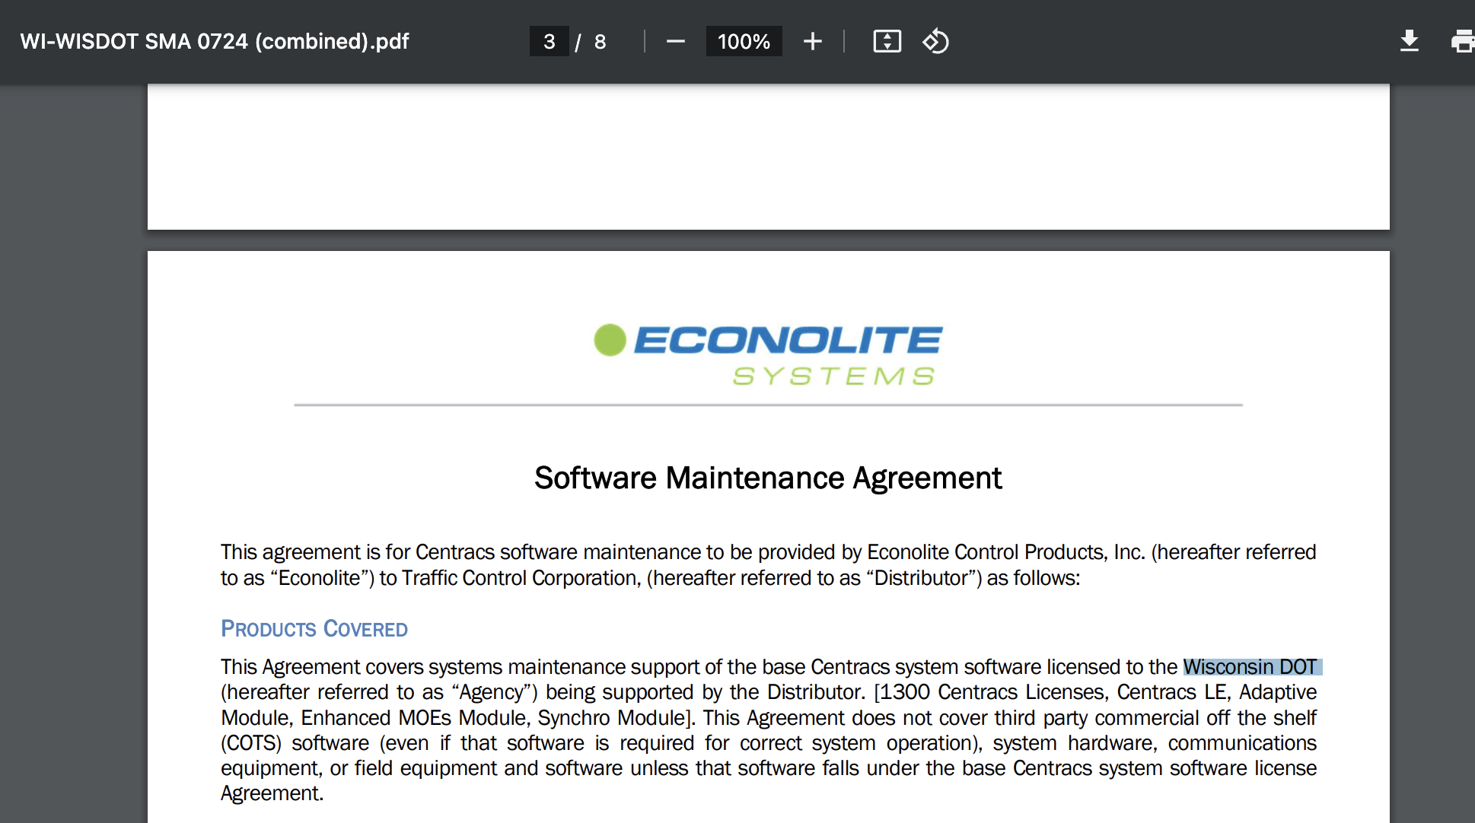

* **Guidance for Processing Items -** Use the description in the section below (highlighted)

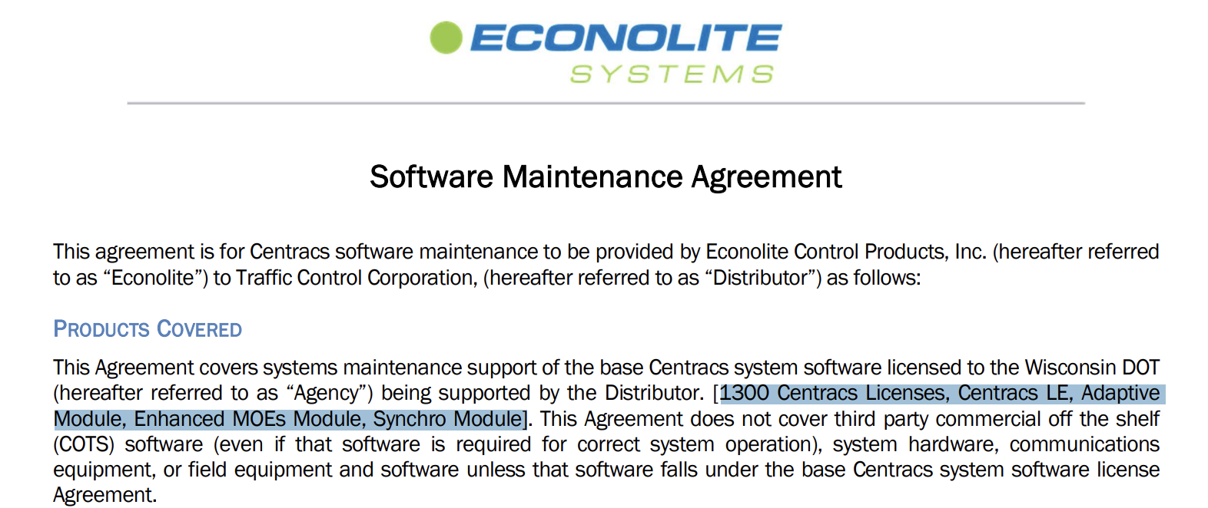

* **Start Date** - Look for Coverage effective Period

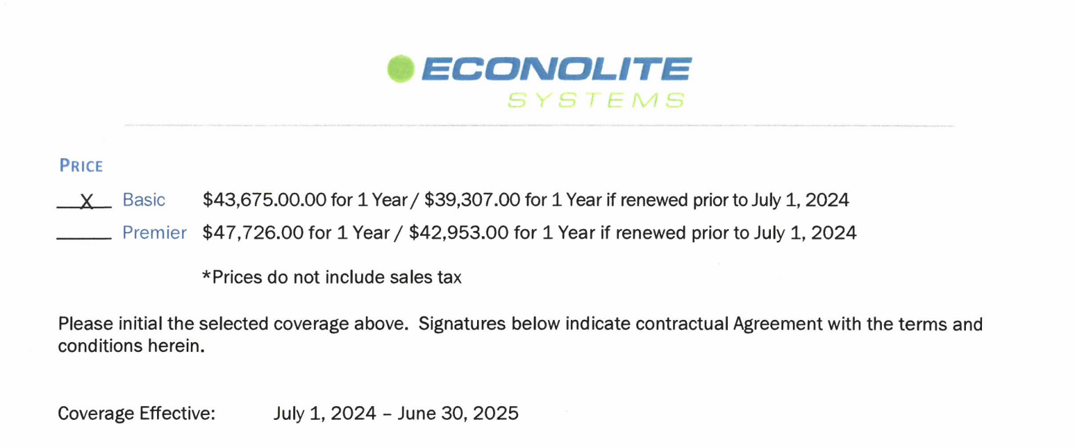

* **Typical Cadence:** Either 1 year (most common), 2 years or more years
  + Please note that there’s times where it's more than 1 year of contracted terms. Make sure that these are captured correctly.
  + This is an area where they care immensely about accuracy
* **Net Terms:** Based on contract
* **Purchase Order:** Should be in the table (Note, there’s sometimes 2 different P.Os in the contract) The one we want to pick up and add is always in the Excel spreadsheet, see example below.

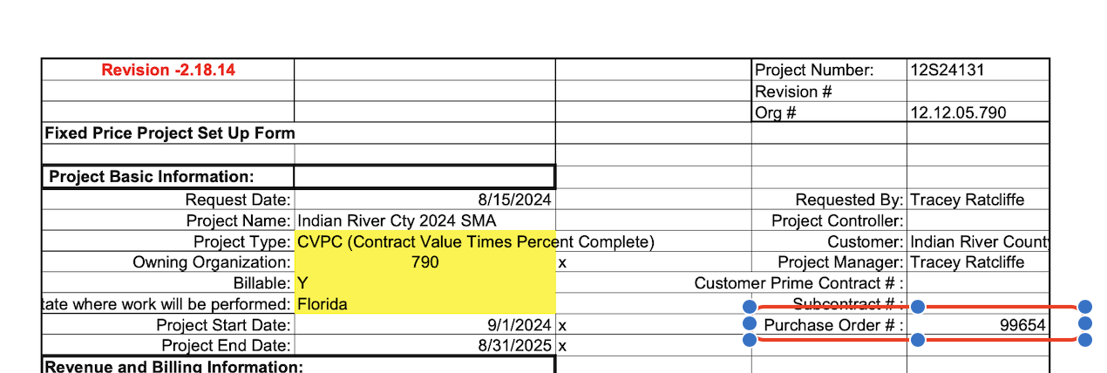

* **Pricing:** Look at the signature date to confirm that they have locked in early pricing or preferential pricing. In this case yes.
  + They have also started updating contracts and making sure that they have clearer boxes for these for easier pricing review

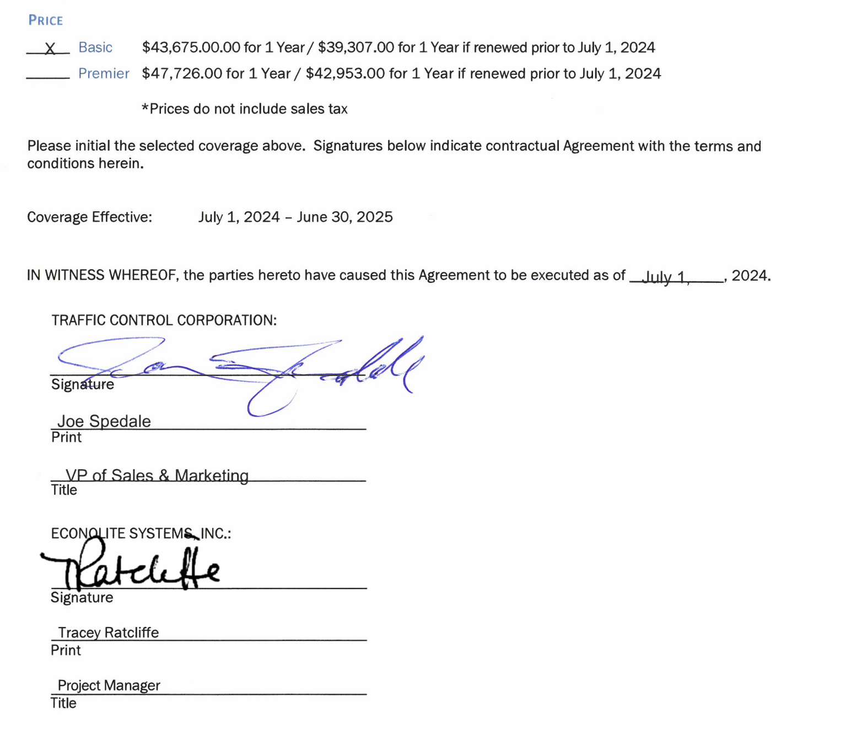

### Feature Requests

* FR 1
  + What is it
  + Why it's important
  + Urgency

### Rewatch Calls

* Rewatch by dates